**BLG556E-Digital Solutions for Smart Cities, Spring 2017**

**Take Home Final Exam/Project**

In this take home project, you are asked to write a computer simulation to analyze the waste collection of a city under the given scenarios. Finally, you should write a report and provide your codes through Ninova.

Assume that you are responsible for the collection of wastes of a fictional city. The structure of the city is given in the following figure. In the figure black grid lines represent the roads.

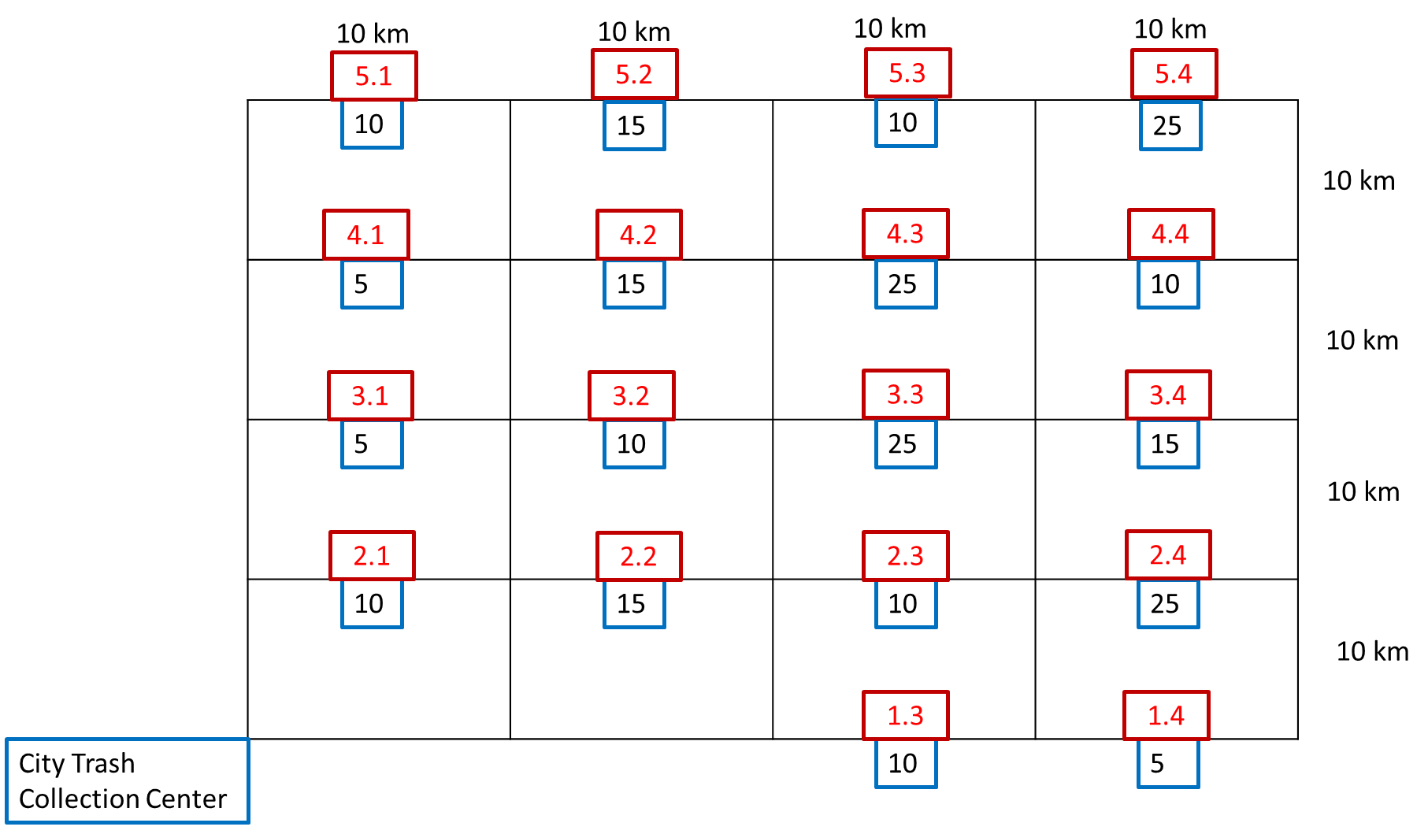

The grid above represents the streets of a city. Each segment of the grid (horizontal and vertical) is 10 km long as shown in the figure.

In the figure, blue boxes represent trash bins which are placed at the equal distance location from either end of the corresponding segment (street) and has 50 kg capacity. The IDs of bins are given in red boxes. Arrival of waste to each bin is represented by a Poisson distribution that are parametrized () by the numbers in the blue boxes, for example waste arrival rate to Bin#1.4 is 5kg/hour. Wastes in the bins are collected by the trucks of the municipality and for the sake of simplicity we assume that they have infinite waste collection capacity.

The cost of collecting trash is 3.5 $ per km for each truck. If there is an overflow at a bin, additional cost of 20 $ per bin should be considered.

1. You are asked to do 24-hour analyses for the following scenarios.

**Scenario#1:** Every hour a truck leaves the Trash Collection Center in order to collect wastes passing through every trash bin. You are asked to compute the total cost of collecting wastes for 24 hours.

**Scenario#2:** Assume that some sensors are deployed at each trash bin. Whenever a trash bin is full up to the half of its capacity (25 kgs in our case), it sends an alarm to the Trash Collection Center. When the center receives alarms from at least X bins, a truck is sent to collect the wastes from those specific bins from the center. (Note that the truck follows the shortest path to collect trash from those bins)

* Analyze the total cost of collecting wastes for X =2, 4, 6, 8 and 10.
* Give the shortest paths, and the average length of the paths for X =2, 4, 6, 8 and 10.

1. Discuss what will happen when the capacity of a truck is fixed. Write your solution suggestions.
2. Discuss how the trash collection method explained in Scenario#2 could be enhanced.